Can you create a poster about Spring?  What happens in Spring?  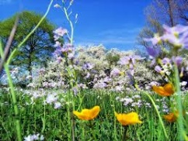 | We will be practicing counting in 2s. Can you find different things that come in 2s?    CHALLENGE - Can you count to 100 in 5s and 10s? | Can you write some clues for the rest of the class to guess what body part you are describing?  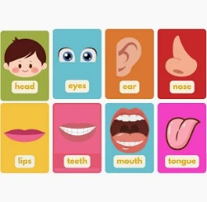 | We will be looking at the types of jobs people might have in Kenya. What do you want to be when you are grown up?
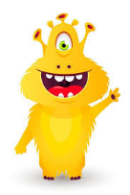  Can you colour in the real words in one colour, and the alien words in another? | Year 1 Spring Term 4  Learning Log  African Adventure |  | We will be learning about length, height, mass and volume. Can you order some of your favourite toys from shortest to tallest and heaviest to lightest?
We have been practicing our blending, especially spotting split digraphs. Can you write down as many words as you can that have split digraphs? | 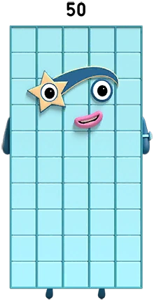  Can you make numbers to 50 using 10s and 1s? |   Can you practice your addition and subtraction number sentences to 20? | 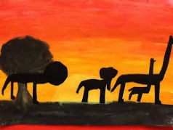  Can you make an African painting or drawing? It can be of an animal, or a landscape, whatever you like!

