Charles Darwin & The Voyage of HMS Beagle
Spring Term – Homework

In the grid below are your different homework tasks for the spring term. Please choose at least 8 pieces of homework to complete this term. You do not need to hand in one every week but by Thursday 2nd April, you should have handed in 8 pieces of home learning.

  Write a setting description of the Galapagos Islands, where Darwin visited during his journey. Try to use powerful vocabulary and some of the different features we have learnt about this year e.g. figurative language, parenthesis, semi-colons etc. |  |  |  |  |  | 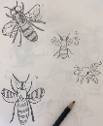  When Charles Darwin travelled the world, he kept lots of different sketchbooks where he drew the different plants and animals he saw. Make six observational sketches of some plants or animals you’ve seen and remember to label each one!
Solve the animal puzzles. The animals represent a different number in each puzzle. | 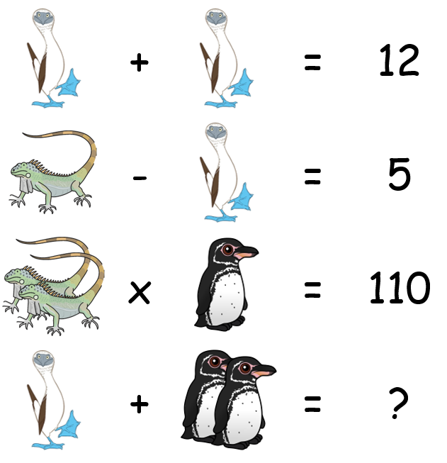 |  |  |  | 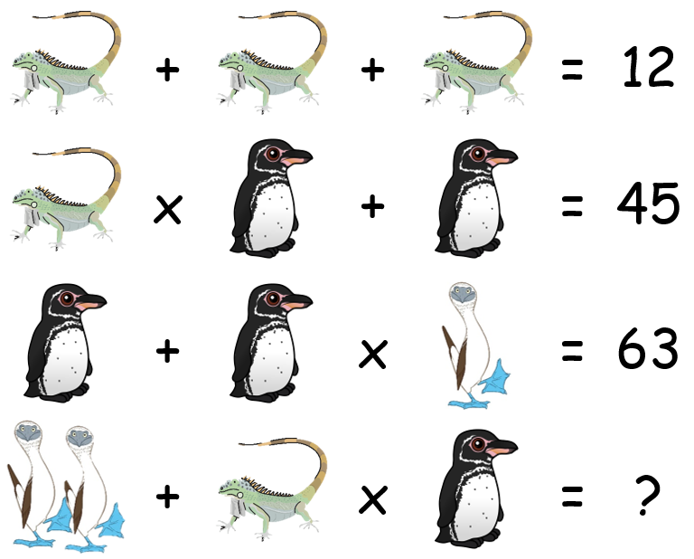
Imagine you need to design a flag for The Beagle that tells people all about who they were and what they did. Think about the things that are important to the crew and what they do. |  |  |  | Mary Anning was a famous fossil collector. Find out about her and present your information in your own way. |  | Find out about one of the countries Charles Darwin visited on his voyage (not the Galapagos Islands as we are learning about those in school). What can you find out about the country?  You can find a list of the places he visited here:  www.amnh.org/exhibitions/darwin/a-trip-around-the-world/a-five-year-journey
Choose one animal to research and find out how it has adapted to help it to survive in its environment. Make a poster to explain how this creature is adapted to its surroundings. |  |  | Charles Darwin saw lots of species of penguins on his journey around the world.  Try and solve this penguin problem with the information below:  • 3 penguins ate 30 fish. They each ate a different number of fish.  • The amount of fish the first penguin ate was a 1- digit prime number.  • The amount of fish the second penguin ate was a prime number.  • The second penguin ate more than half of the fish.  How many fish did the third penguin eat?
Charles Darwin was interested in all types of animals and plants, especially ones which were extinct. Find out about a creature which is now extinct and create a fact file. Some examples are: dodo, sabre-tooth tiger, great auk, woolly mammoth and quagga. Find some more here: https://onekindplanet.org/top-10/top-10-worlds-extinct-animals/ |  |  |  |  |  |  | 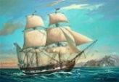  Write ten questions you would like to ask Charles Darwin. These could be to do with his voyage around the world on HMS Beagle or about evolution or inheritance.
Create a true or false quiz about Charles Darwin and his expedition on HMS Beagle. |  | Imagine you are the young scientist, Charles Darwin, out on his expedition on HMS Beagle. Write an extract from his journal that describes part of the journey. It could be the start of the voyage, arriving at one of the islands, or discovering different animal species. |  |  |  |  |  | What can you discover about Lonesome George, the last ‘giant Pinta Island tortoise’ from the Galapagos?

 |  | 
Log in to Spelling  Shed to practise your spellings. | Practise your times tables online. | You should be reading at home at least 4 times each week. Remember to record your reading in your contact book. When you’ve finished a book, you can do a quiz in school.

