Geography  In Geography, we are learning about the United Kingdom.  Your task is to choose any country in the world that you would like to find out about!  🌎 You need to find out things like:  *What is the weather like there? *What do people eat?  *What are some famous landmarks or animals?  *How is it similar to or different from the UK?  Present your work in any way you choose  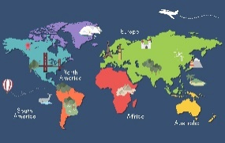 | English  In English, we are going to write letters as a character about their visit to a different country.  I would like you to write a letter to someone to tell them about:  A real place you have visited, or  A pretend visit to somewhere you would like to go  🖊️ Things to include in your letter:  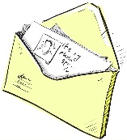  Who you are writing to  Where you went  What you saw and did  What you liked or found interesting  How you felt about your visit | English  In English, we are going to be writing descriptions of characters.  I would like you to choose your favourite character and write a description of them.  📌 Remember to include:  What they look like – hair, eyes, clothes, height.  How they act – are they kind, brave, silly, or clever?  Anything else important – their favourite things, special skills, or how they make others feel  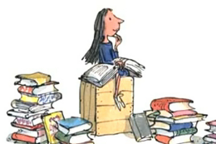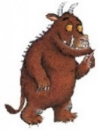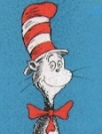
English/D.T  In class we are going to be writing instructions to help Paddington bear make a marmalade sandwich! I would like you to try cooking or making at home and then write instructions to tell me know how you made it. | Year 2 home learning Menu  Remember to record all of your home learning in your book and return 3 pieces across the term |  | Reading  Last term, we took photos of our class reading in unusual places around school. This term, I would like you to find an unusual place to read and take a photo for the class display!  Photos can be emailed to the Year 2 email address.  Or print it yourself and bring it into school.  Be creative and have fun finding the most unusual reading spot!  FREE CHOICE!  Surprise me with something amazing
D.T  Create a 3D model of a famous London landmark.  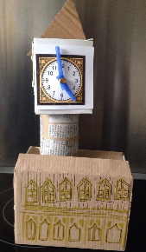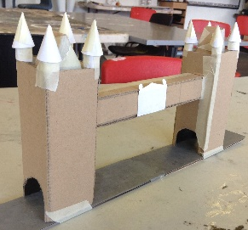 | 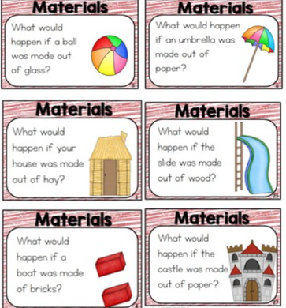  Science  We are continuing our ‘Uses of materials’ topic.  I would like you to pick some of the statements and explain what would happen if…  Tell me if you think it would be a good idea or not!

