History  In class we are going to be finding out about holidays in the past.  Interview someone in your family, a neighbour, or a family friend about the holidays they went on when they were younger.  - Where did they go?  - How did they get there?  - What did they do?  - How were their holidays different from yours? | Science.  This term we are going to be learning about the use of everyday materials.  - Go on a material hunt at home! Find objects made from wood, metal, glass, cloth, or stone/brick.  - Draw and label the objects.  Challenge: Write a short description of what each object is used for.  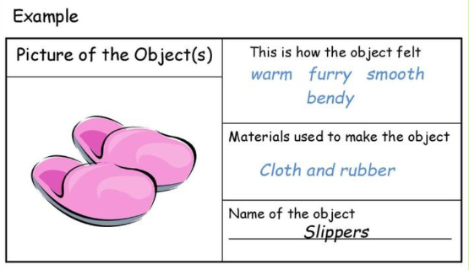 | English - Postcard  Imagine you are a pirate on an adventure!  Write a postcard to someone at home describing:  - Where you have been  - How you got there  - What you have been doing  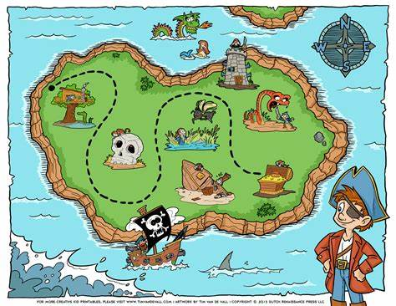
D.T  Be creative with a shoe box!  Using a shoe box or small box create a model linked to our theme of  ‘oh, I do like to be beside the seaside’  For example: a seaside in a box, treasure chest or pirate ship!  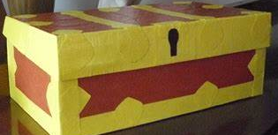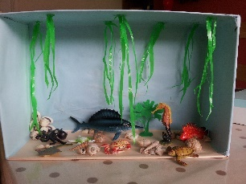  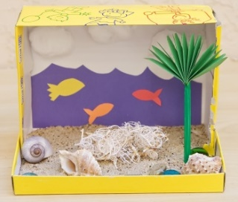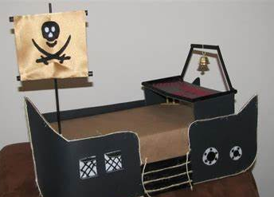 | Year 2 home learning Menu  Remember to record all of your home learning in your book. | Geography / Science  Research an animal that you would find at a British seaside.  Present your facts in an interesting way.  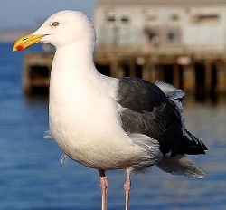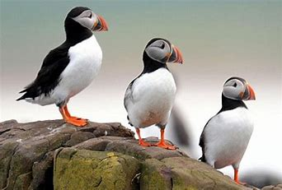  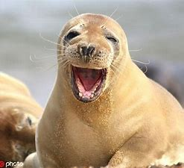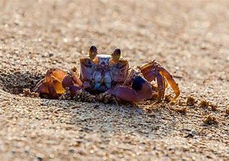  ART  Make a model of a seaside artefact or feature (e.g. shells, buckets, boats, or a crab).  OR  Draw or paint a seaside landscape.
PSHE
Create a safety poster about keeping safe at the seaside.
You could include:
- Keeping safe in the sun
- A list of items to bring along with you
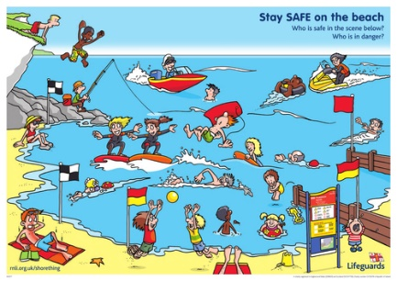
FREE CHOICE!  Surprise me with something amazing | English  Write your own short seaside adventure story.  It can be about anything linked to the sea or seaside!

